CS 623 - **Database Management Systems**

Final Project - **Flight Tracking System**

Professor – John Agar

Team Members –

1.Sai Gnandeep Vangapandu(**U01859740**)

2.Sai Swaroop Manne (**U01952611**)

3.Venkata Padmavathi Dhanakudharam(**U01944105**)

4. Kavya Sri Myakala(**U01948981**)

5.Ramyasri Karuturi(**U01938752**)

**Schema:**

**destinations Table:**

id (INT, AUTO_INCREMENT, PRIMARY KEY): Unique identifier for each destination.

name (TEXT): The name of the destination.

price (DECIMAL(10, 2)): The price of the flight to the destination.

This table stores information about various destinations available for booking flights. Each destination has a unique identifier, a name, and a price associated with it.

**bookings Table:**

id (INT, AUTO_INCREMENT, PRIMARY KEY): Unique identifier for each booking.

customer_name (TEXT): The name of the customer who made the booking.

destination_id (INT): Foreign key referencing the id column in the destinations table, indicating the destination booked.

Bookings made by customers. Each booking has a unique identifier, the name of the customer who made the booking, and a reference to the destination booked. The destination_id column establishes a relationship with the destinations table, indicating which destination the booking is for.

**Entities:**

**Destinations:**

**Attributes:**

id (INT): Unique identifier for each destination.

name (TEXT): The name of the destination.

price (DECIMAL(10, 2)): The price of the flight to the destination.

**Bookings:**

**Attributes:**

id (INT): Unique identifier for each booking.

customer_name (TEXT): The name of the customer who made the booking.

destination_id (INT): References the id column in the destinations table, indicating the destination booked.

**RealtionShips:**

**destinations Table:**

id (INT, AUTO_INCREMENT, PRIMARY KEY): Unique identifier for each destination.

name (TEXT): The name of the destination.

price (DECIMAL(10, 2)): The price of the flight to the destination.

**bookings Table:**

id (INT, AUTO_INCREMENT, PRIMARY KEY): Unique identifier for each booking.

customer_name (TEXT): The name of the customer who made the booking.

destination_id (INT, FOREIGN KEY): References the id column in the destinations table, indicating the destination booked.

**Relationships:**

Each booking in the bookings table is associated with one destination from the destinations table. This relationship is established through the destination_id foreign key in the bookings table, which references the id primary key column in the destinations table.

This relationship ensures that each booking is linked to a specific destination, allowing for easy retrieval of booking details along with the corresponding destination information.

**ERD:**

**Flight Tracking System:**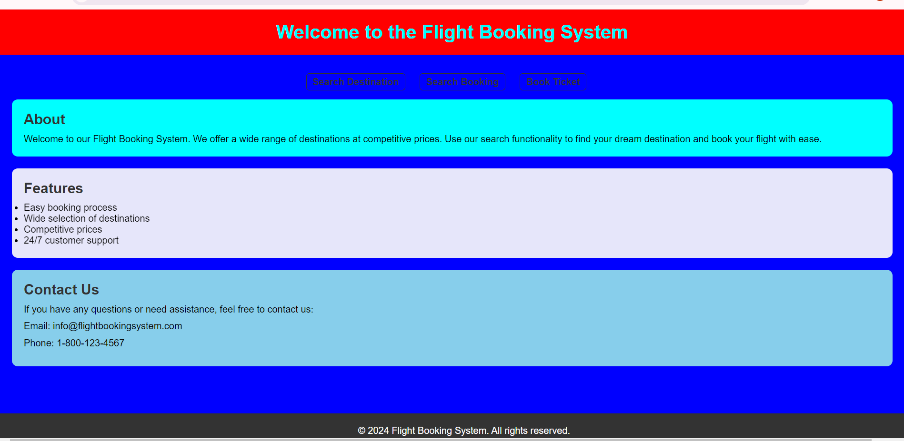

**Key Features:**

**Destination Search for Customers**

Customers can search for destinations (e.g., USA) and view corresponding prices.

**Customer Details for Flight Operators**

Flight operators can easily search for customer details along with their booked flights.

**Booking Form with Validations**

Customers can book tickets through a user-friendly interface with built-in validations.

**Destination Search Feature**

Interface for the customers to make a choice between destinations.

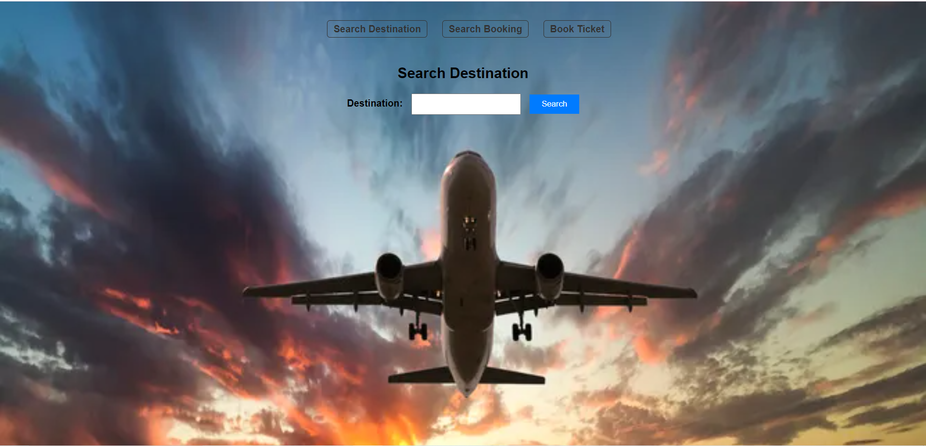

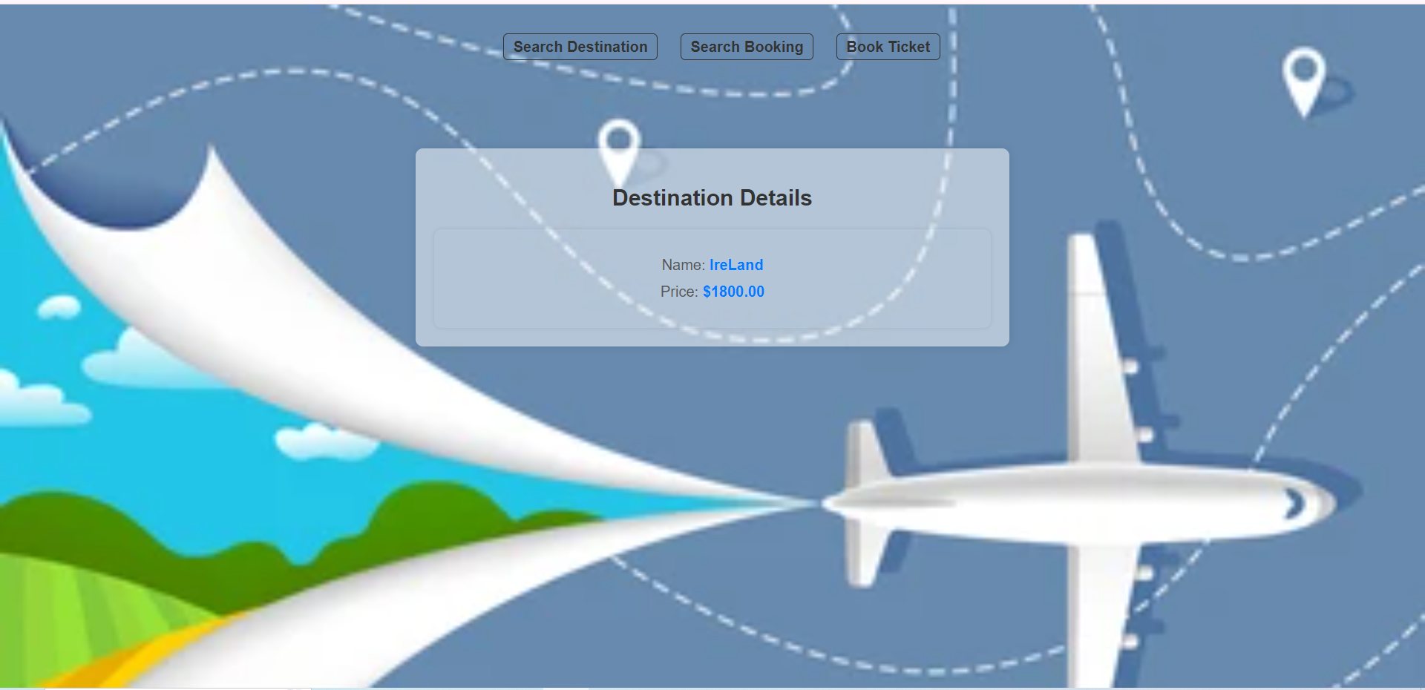

Description: The easy-to-use search function permits the clients to important cities and they can do the comparison of fares in a quick span of time.

**Customer Details for Flight Operators**

Interface, which is an operating display for a flight operator to conduct customer data search.

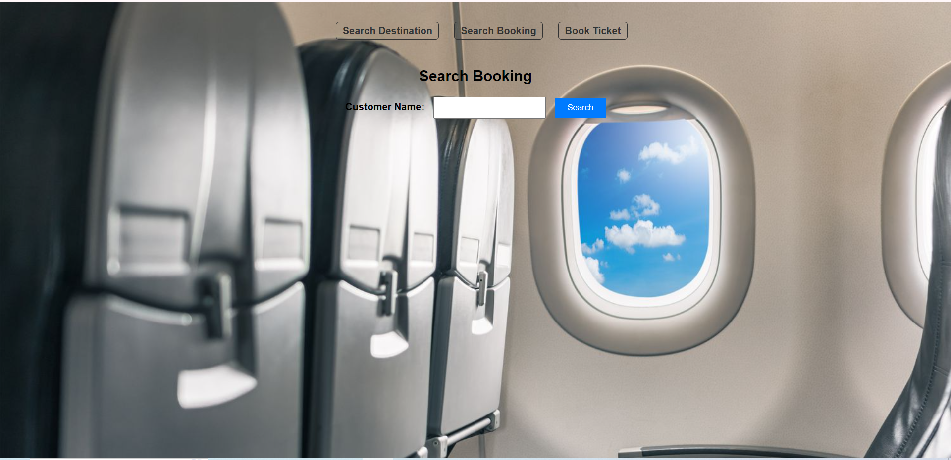

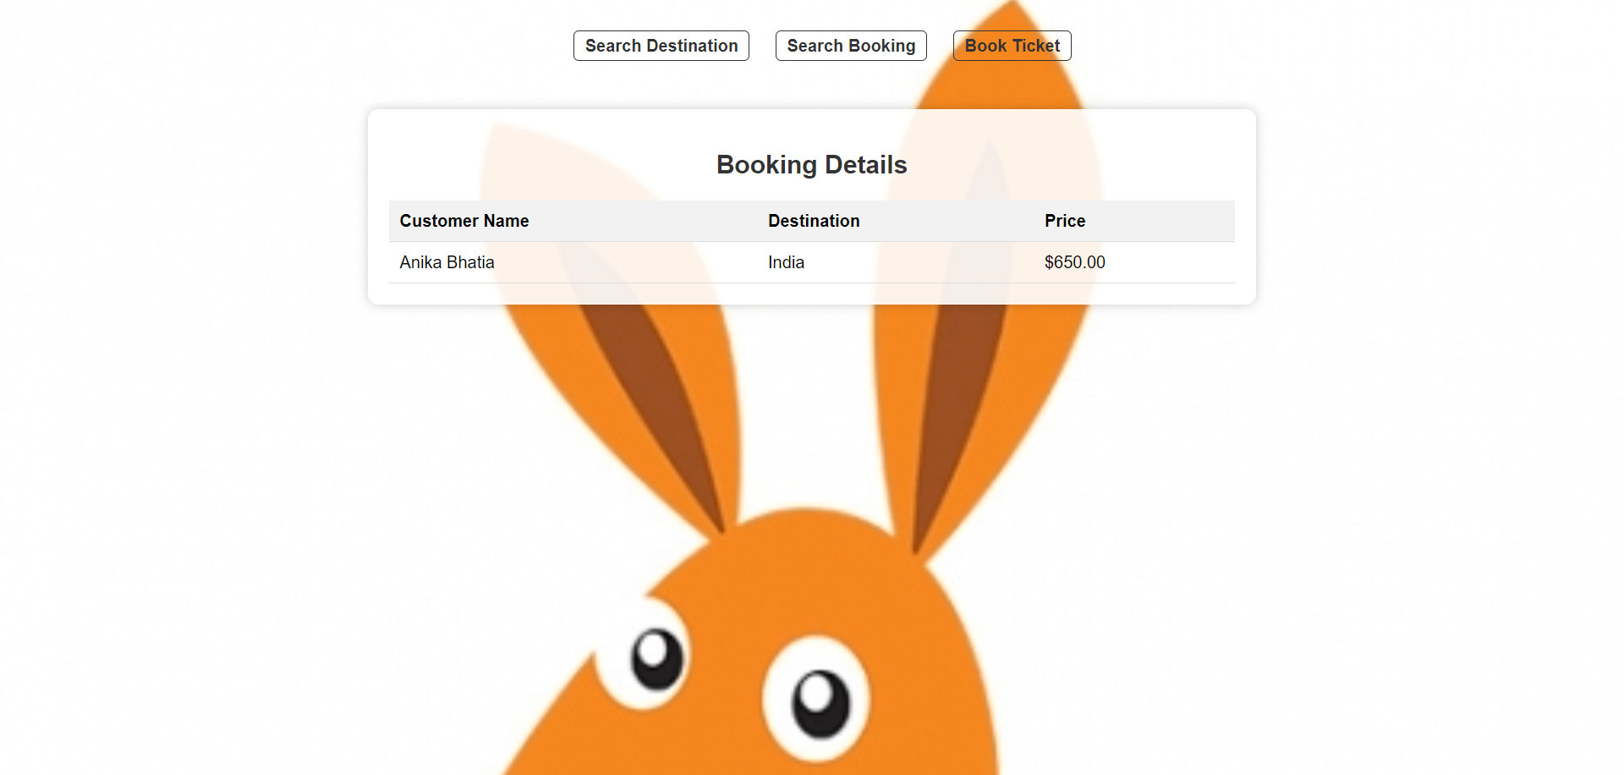

Description: Flight staff members can do the job quickly and manage customer information and bookings with a detail-oriented search feature.

**Booking Form**

Form which checks with validation checks

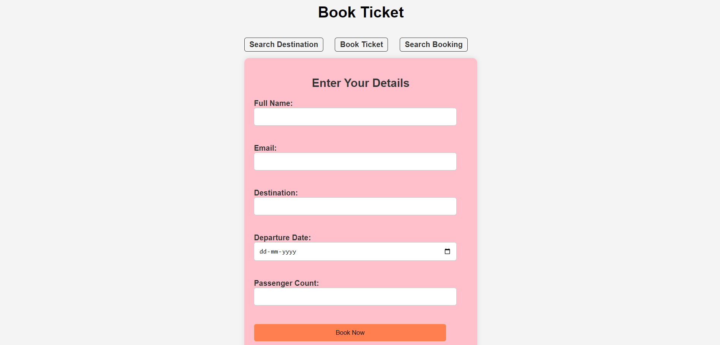

Description: Customers can spend time traveling while worrying through a simple booking form with built-in validations to ensure they fill all the right fields.

**Benefits**

**Efficiency:** Smooth-running of both customers and flight operators at the airports.

**Accuracy:** Validations make right booking and fleet management.

**Enhanced Customer Experience:** One of the most important features of a website is its user-friendly interface which leads to customer satisfaction.

**Improved Management:** Comprehensive system of booking management (CRM) and client data is set to be launched.

**Use Cases**

**Customer Perspective:** Manoj would like to make an airplane reservation to theUSA. He viewed the flight search tool and looked for available flights and prices.

**Operator Perspective:** Sarah as a Flight Operator will need to retrieve customer records for the booked trip she was assigned. The search customer details feature helps her to rapidly obtain the required information.